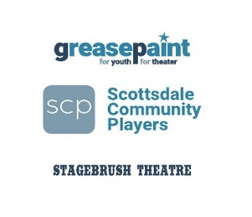
Dear Community Member,

On March 24th, 2018, Greasepaint Youththeatre will be hosting its annual fundraising event “at home” at Old Town Scottsdale’s historic Stagebrush Theatre. Our goal is to raise enough money to fund the 2018-2019 season that will include 6 full-length musicals, involving more than 225 local performers ages 6 – 19, and will employ over 70 working directors, musicians, and technical professionals from the Valley’s artistic community. It’s a community effort to keep the arts in our world and we need your help!

Greasepaint enters its 34th year as a professionally-directed community theatre, located in the historic Stagebrush Theatre in Old Town Scottsdale, specializing in youth performances of the highest quality. We support youth from all backgrounds. And youth from Greasepaint have gone on to become Broadway, television and film actors as well as Doctors, Engineers, Lawyers, teachers, parents and leaders in their communities! Our theatre gives children a unique means of expression, capturing their passions and emotions, and allowing them to explore new ideas, subject matter, and culture. Theatre also broadens their understanding of the world around them. Our theatre is 100% funded by local donations and ticket sales; therefore, all support directly impacts arts in our community.

Please consider donating an item/service for our auction or making a monetary donation. We will acknowledge all businesses and individuals on our website, in our final show program, and in our event email blasts. We reach more than 7,000 local families! You may also donate anonymously, of course!

If you have any additional questions, please contact Maureen Dias- Watson at moedias@greasepaint.org (480)949-7529. Your support and generosity are greatly appreciated!
On behalf of the families and children who call our theatre home, we thank you!

SCP/GREASEPAINT IS A 501 (C) (3) ORGANIZATION, TAX ID: 86-6050982

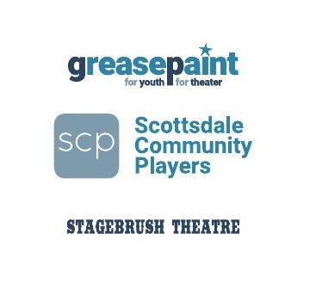

Donor Information: ITEM OR SERVICE

Contact Name: _________________________Email: ___________________________________

Item Donated:

___________________________________________________________________________

Donor Name: (as it should appear in Gala Materials) Please let us know if you would like to remain anonymous.

________________________________________________________________________________

Address: _____________________________________________________
City: ______________________ State: ______ Zip: ____________________
Telephone: _________________________________________

Estimated Value of donation (Required): $________________________

Donation Description: (Please specify color, size, quantity, limitation, expiration date, etc.)
________________________________________________________________________________________________________________________________________________________________________________________________________________________________________________________________________________________________________________________________________________________________The above described item is (please check one):
❑ Included with this form
❑ Will be mailed or delivered to the Stagebrush Theatre (Home of GREASEPAINT)
❑ Need item picked-up

I WOULD LIKE TO DONATE / SPONSOR / ATTEND THIS EVENT!

____Enclosed is a check in the amount of ______

____Please charge my credit card ____AMEX ____VISA ____MASTERCARD

______________________________________card number _____________exp _____CVN

______________________________________signature

PLEASE KEEP A COPY OF THIS FORM TO SERVE AS YOUR RECEIPT.
SCP/GREASEPAINT IS A 501 (C) (3) ORGANIZATION, TAX ID: 86-6050982
Please send form to: GREASEPAINT * 7020 E 2ND ST * SCOTTSDALE AZ 85251
MOEDIAS@GREASEPAINT.ORG (480) 949-7529

THANK YOU

